Washington Native Plant Society
Central Puget Sound Chapter
May 5, 2022

Update on Seattle Area Sword Fern Die-off
Dr. Tim Billo

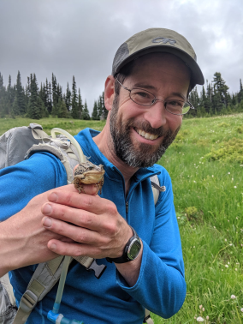
Photo credit: Tim Billo

The mystery is not yet solved! In November of 2016 Dr. Tim Billo introduced us to a local botanical disaster. For several years, sword ferns in an area of Seward Park had been dying, and the problem was getting worse. He continues to work with a team of scientists and community activists to unravel the issue and will summarize the results of the large ongoing collaborative effort in Seward Park and other sites around the region. He’ll review the multiple etiologies that have been explored and share the hypotheses the research team has developed. He will also share the team’s ongoing experimental work testing hypotheses and restoration solutions. Finally, Dr. Billo will place this challenge in the context of anthropogenic climate change and other human pressures.
Dr. Tim Billo is a lecturer with the University of Washington Program on the Environment. The focus of his position is undergraduate teaching. He teaches a wide range of interdisciplinary courses, often centered around field studies and natural history. Here are links to two of his summer courses: https://sites.uw.edu/gb2018uw/ and https://sites.uw.edu/envir3802021/
Dr Billo’s PhD is in biology, with a specialty in bird behavior and evolution, with much of his research taking place in lowland tropical rainforests of Central America. With a lifelong interest in plants, however, and two small children at home, he welcomed the opportunity to work on the sword fern die-off problem affecting Seward Park, a field site in his own neighborhood!
Our plan is to make this our first in-person meeting since the pandemic started. So as always, please check our event web site for any updates: https://www.wnps.org/cps-events/calendar/1555

Thursday, May 5, 2022 7:00 PM
The Garden Room at the Brig Building # 406 in Magnuson Park, 6344 NE 74th St, Seattle, WA 98115
https://sci.washington.edu/summit2017/Brig%20Floor%20Plan.pdf
Admission is free! Public invited!
Upcoming Programs:

9-1-22 Andy McKinnon, “Magic Mushrooms” (Members only)

10-11-22 Dr Fred Rhoades, “Introduction to Mushrooms and Mushrooms Through the Year “

11-3-22 Chris Earle, “The Gymnosperm Database”

